The brief
The new aiondigital.com has one job: in the first 10 seconds a bank executive sees a real Saudi banking journey running on a phone, and thinks "they have already built this."
The current site fails that test. The hero says "Bringing Purpose Back to Banking" with no product in sight. It still says 500+ APIs (we have 800+), shows 2021 and 2022 imagery, and sends onboarding to a separate eKYC subdomain. It reads like every core banking vendor from 2015.
The core idea: make the invisible visible. Aion is the layer behind the bank's app. Nobody sees an API. So every page shows two things at once: the customer journey on a tilted phone, and an "under the hood" switch that reveals what Aion did in those seconds (Nafath, Wathq, SIMAH, core banking, the decision). Business readers see the experience and the KPI. Technical readers flip the switch and see the architecture. Same demo, two audiences.
Who we are talking to, in order:
- Bank CXOs (CEO, Head of SME, Head of Retail, CDO). They give us 10 seconds and want an outcome.
- Bank CTOs, CIOs and architects. They want proof it is real and modern, and will dig.
- Investors, partners and future hires. They want to see a serious company.
What success looks like: a visitor watches at least one demo end to end, clicks into a second, and books a walkthrough or messages us on WhatsApp.

Rules for the team
Ten rules. If a page breaks one, it goes back.
- Product before words. Every page opens with a moving journey, never a slogan, a stock photo or an abstract graphic.
- Three lines maximum beside any demo. If it needs more, the demo is wrong.
- Saudi-specific, always. Name the rails banks know: Nafath, Wathq, SIMAH, SADAD, SARIE, mada, Mudad/WPS, GOSI, ZATCA. Generic "seamless onboarding" is banned.
- One KPI per demo, the one a board member cares about: time to account, cost to acquire, cost to serve, drop-off, straight-through rate, RM hours saved.
- Every number is defensible. Only figures from a live deployment or a stated benchmark, with the source in a footnote. No invented percentages.
- 30 seconds, silent, looping. Demos autoplay muted with on-screen captions. Nobody turns sound on in a bank office.
- No buzzwords. Banned: seamless, cutting-edge, best-in-class, holistic, synergy, unlock, empower, revolutionise, next-generation.
- Arabic from day one. Full RTL Arabic version at launch, not "coming soon." Saudi bank executives notice.
- No client screens, no client branding. Every demo runs on a fictional Aion reference bank (see Proof and trust).
- Fast. Page loads in under 2 seconds on a phone. Video compressed, lazy-loaded below the fold.

Homepage, scroll by scroll
The homepage is a product screen, not a brochure. Six scrolls, nothing more.
Scroll 0: the hero (the 10-second test)
White background, Aion teal accents. Right side: a phone tilted about 15 degrees, playing the hero journey on a 30-second loop. Left side: three lines and two buttons. Above the phone, a row of journey chips so the visitor can switch the demo without leaving the page. Below the phone, a thin progress bar naming each step as it happens. A small switch under it reads Show what's behind it.
Hero journey: a three-owner Saudi LLC opens a business account on a phone.
Draft copy (left side):
A three-owner LLC. Business account open on a phone. Every owner approves through Nafath. The CR comes from Wathq. No branch visit, no paper. Running on Aion inside a Top 5 Saudi bank.
KPI badge on the phone: Time to account: [X] minutes, live deployment. Fill [X] only with a measured figure.
Journey chips: SME onboarding · Bulk payroll · SADAD and government payments · SME card and spend · Cash-flow lending · RM early warning (AI).
Buttons: Book a 20-minute walkthrough (calendar link, two fields only) and Message us on WhatsApp.
When the visitor flips Show what's behind it, the phone slides left and a live trace appears on the right: each call lighting up in sequence with its time stamp. Nafath authentication, Wathq CR lookup, owner consent, SIMAH check, AML screening, core account creation, card issued. This one switch is what makes us different from every other bank vendor site.
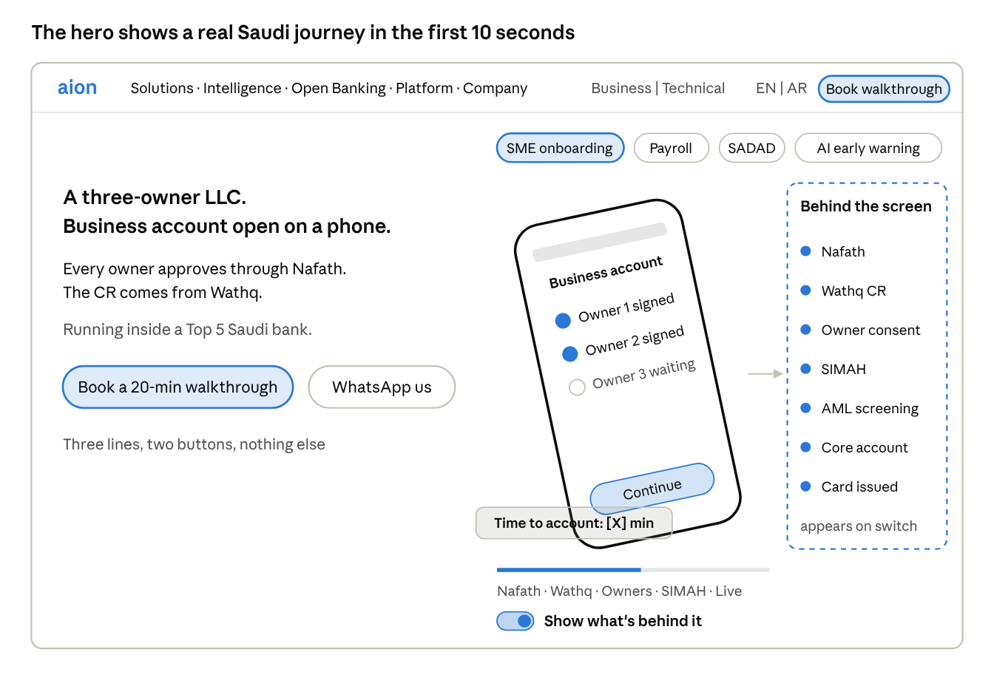
hero layout sketch · not a final design
Left: three lines and two buttons. Centre: the tilted phone running the journey, chips to switch it. Right: the trace that appears when the switch is on.
Scroll 1: pick your journey
A grid of demo cards by segment: SME, Retail, Corporate, AI, Open banking and embedded finance. Each card is a looping 6-second thumbnail with one line. Click opens the full 30-second demo in a focused view (see Demo library).
Scroll 2: what sits behind every screen
One animated layer diagram, three bands. Top: the bank's apps and channels. Middle, in teal: the Aion layer (Rubix, 800+ APIs, open banking rails, Ai966 intelligence). Bottom, grey: the bank's existing core, labelled "unchanged." One line under it:
Your core stays. We add the layer that makes it move.
Scroll 3: four numbers
Four plain tiles, no icons: 9 years in Saudi and GCC banking · 800+ banking APIs · 3 open banking licences (SAMA, CBB, FCA) · a full SME banking business live in about 6 months. Each with a source line on hover.
Scroll 4: proof
Client logos (only those with written permission) and one short quote from a named bank executive, if approved. If not approved, use the logos alone. Never an anonymous quote.
Scroll 5: shipped this month
A short, dated list of what we released in the last 30 days, three to five lines. It proves velocity better than any claim. Updated monthly, owned by the product team.
Scroll 6: close
See it on your own journeys in 20 minutes.
Same two buttons. Footer: Riyadh, Manama, Karachi. Arabic toggle visible top right on every page.
A note on the global switch. Put a lens toggle in the top bar: Business view / Technical view. Business view shows KPI captions on every demo. Technical view swaps them for architecture captions (services called, latency, deployment pattern). One site, two readers, no separate microsite.

Navigation
Five top-level items, one button, two toggles. Every item under Solutions opens a demo, not a text page.
Menu | What sits under it
Solutions (mega menu by segment) | SME: digital onboarding (LLC, multi-owner, sole proprietor) · business accounts and sub-accounts · bulk payroll (Mudad/WPS) · SADAD and government payments · SME cards and spend management · financing request journey · banking inside the SME's ERP
 | Retail: onboarding with Nafath · accounts and instant transfers · cards and wallet · personal finance view
 | Corporate: bulk payments with maker-checker approval · liquidity and cash view · approvals on mobile · ERP and host-to-host connectivity
 | Wallets and BaaS: white-label wallets · banking as a service for telcos, fintechs and corporates
Intelligence (Ai966) | Early warning · next best product · customers hiding in the payment file · retention · capital allocation (preview) · policy copilot · how every result is measured
Open Banking | SME cash-flow lending · mortgage affordability · Engage (personal finance) · Nomou (business finance) · consent and compliance · embedded finance in ERP · our licences (SAMA, CBB, FCA)
Platform | Rubix architecture · API catalogue · security and compliance · deployment options
Company | About · leadership and board · careers · Aion Connect · contact
Right side of the bar | Business / Technical lens toggle · EN / عربي toggle · Book a walkthrough button
What we drop from today's menu: the separate eKYC subdomain (fold it into SME and Retail onboarding, with redirects), and Resources unless someone owns publishing at least monthly. An empty blog hurts more than no blog.
Open question for the product team: do we have a public API sandbox or docs portal we are comfortable exposing? If yes, add Developers as a sixth item. If not, keep the API catalogue as a read-only list under Platform.

Demo library
Launch with four demos (SME onboarding, payments, early warning, cash-flow lending), add the rest at two per fortnight. Each demo comes in two forms: a 30-second silent loop on a tilted phone, and a clickable prototype behind a Try it yourself button.
Every demo follows the same template:
- Seconds 0 to 30: five or six beats, one screen each, captions on screen.
- Side copy: three lines. Line one is the outcome. Line two is the Saudi-specific how. Line three is the proof.
- Board KPI: one number, sourced, in a badge on the phone.
- Under the hood: the trace of services and rails that appears when the switch is on.
- Spec: MP4 and WebM, 1080p, under 2 MB, loops cleanly, a still poster frame, captions in English and Arabic.

Wave 1: at launch
1. SME onboarding: three-owner LLC (homepage hero)
- 0 to 30s: owner taps Open business account → approves with Nafath → enters CR number, Wathq returns company and owner details → the two co-owners get a link and approve with Nafath on their own phones (three small phones side by side) → SIMAH and screening checks tick through → account live, IBAN shown, virtual card issued.
- Side copy: A three-owner LLC. Business account open on a phone. / Every owner approves through Nafath. The CR comes from Wathq. / Running inside a Top 5 Saudi bank.
- KPI: time to account, measured. Second option: drop-off rate versus branch.
- Under the hood: Nafath, Wathq, owner consent service, SIMAH, AML screening, core account creation, card issuing, each with a time stamp.
2. Payments: the full stack, then the flows
Open with one 6-second shot of every rail the platform runs: SARIE, instant payments, SADAD, mada, bulk and payroll, international. Then three 30-second flows:
- 2a. Bulk payroll. Payroll file pulled from the ERP or uploaded → two errors flagged before release (wrong IBAN, missing ID) and fixed inline → maker submits, checker approves on mobile → WPS file prepared for Mudad, salaries released. Copy: Payroll for 120 staff, approved from a phone. / The WPS file is built automatically. / Errors are caught before the money moves. KPI: errors caught before release, or cost to serve per payroll run.
- 2b. SADAD and government payments. Owner sees what is due this month: ZATCA VAT, GOSI, municipality, utilities → selects four, pays in one action → checker approves → receipts filed, next month's dues forecast. Copy: Every government and utility bill in one place. / Paid through SADAD in one approval. / Next month's dues forecast before they land. KPI: share of SME payments moved to digital.
- 2c. Supplier bulk payments. Batch of supplier payments routed automatically to the cheapest and fastest rail, with a cash view before and after. KPI: cost per transaction.
3. RM early warning (Ai966)
- 0 to 30s: RM's phone shows a signal: a fictional trading company will likely miss payroll in about 60 days → the reasons appear: balances falling four months running, receivables slowing, VAT paid in part → suggested action: offer a working capital line, with a call script → RM taps call, logs the outcome → a small chart compares this group against the holdout group.
- Side copy: Your SME customer will miss payroll in 60 days. It is already in the transactions. / Ai966 tells the RM who to call, what to offer, and when. / Every result is measured against a holdout group.
- KPI: show the measurement method, not an uplift number, until a bank-wide result exists. This is non-negotiable.
- Under the hood: transaction data, customer state, signal, action, attribution.

Wave 2: within six weeks of launch
# | Demo | The 30 seconds in one line | Board KPI
4 | SME cards and spend | Owner issues cards to five staff, sets limits by category, receipts captured, everything syncs to the ERP | Card spend per SME, cost to serve
5 | SME financing request | Offer pre-built from the SME's own transactions and SIMAH, owner accepts, funds land | Time to decision
6 | Banking inside the ERP | Inside SAP, the SME sees its balance, pays a supplier, and gets a financing offer on an invoice | New SMEs acquired through the ERP channel
7 | Corporate approvals | Treasurer reviews a bulk batch with liquidity view, approves maker-checker on mobile | Approval cycle time
8 | Retail onboarding | Nafath to funded account to first instant transfer | Time to first transaction
9 | Wallet for a telco | White-label wallet launched under a telco brand, top-up, pay, transfer | Time to launch a new brand
10 | Open banking cash view | SME connects accounts at two other banks with consent, sees one cash position | Share of wallet visibility

Open banking: show the product, not the pipe
Nobody buys "account information services." They buy a faster credit decision. Each open banking demo opens on the outcome; the consent and data flow appears only when the switch is on. Engage and Nomou can also run on the bank's own data first, without open banking; consent then widens the view to other banks.
OB1. SME cash-flow lending (joins Wave 1 at launch)
- 0 to 30s: owner applies for working capital → connects accounts at two other banks on one consent screen (what is shared, for how long) → 12 months of statements pulled and categorised → turned into a cash-flow statement: inflows, payroll, VAT, net cash by month → credit decision with a limit and the reasons → owner accepts.
- Copy: Twelve months of bank statements become a cash-flow statement in seconds. / Credit decided on how the business actually trades. / Built on our SAMA open banking licence.
- KPI: time to credit decision, and documents asked of the customer.
OB2. Mortgage affordability (Wave 2)
- 0 to 30s: applicant shares the salary account held at another bank → verified salary, existing commitments, monthly spending → affordability and maximum amount → the underwriter's view shows the evidence behind the number.
- Copy: Verified income and commitments from every account the applicant holds. / Affordability decided in minutes, evidence attached. / No salary certificates, no stamped statements.
- KPI: time to approval in principle.
OB3. Engage, personal finance (Wave 2)
- 0 to 30s: retail customer links accounts across banks → one balance, spending sorted by category → sets a goal (school fees, Umrah) with a monthly plan → a gentle nudge when spending drifts → a savings product offered at the right moment.
- Copy: Every account the customer holds, inside your app. / Spending sorted, goals tracked, nudges that help. / The bank becomes where they manage money, not just keep it.
- KPI: monthly active use of the app.
OB4. Nomou, business finance (Wave 2)
- 0 to 30s: SME owner sees cash across all banks in one figure → 90-day cash forecast → receivables and payables due → ZATCA VAT due flagged → a shortfall shows in week seven, with a one-tap financing offer today.
- Copy: An SME's whole financial position on one screen. / Cash forecast, receivables, payables and VAT due. / The shortfall is seen in week one, not week seven.
- KPI: financing take-up from the forecast.
OB5. Consent and compliance (Wave 2, leads in the Technical view)
- 0 to 30s: customer sees every active consent, what is shared and until when, and revokes one in two taps → switch to the bank's side: consent registry, audit trail for every data call, expiry alerts, a regulator report produced in one click.
- Copy: Every data permission visible, time-bound and revocable. / A full audit trail behind every call. / Licensed in Saudi Arabia, Bahrain and the UK.
- KPI: time to produce a regulator report.

Ai966: show the decision, not the model
Every Ai966 demo ends with a person making a better decision, and the result measured against a holdout group. No dashboards, no model diagrams on the front. All demos run on fictional data, and no uplift figure appears until it is measured at a bank.
AI1. Early warning is demo 3 above, at launch.
AI2. Next best product and sales acceleration (Wave 2)
- 0 to 30s: RM opens the morning list, five customers ranked → taps one: payroll growing, supplier payments rising, no trade finance with us → suggested offer pre-filled → RM sends it in one tap → outcome logged.
- Copy: Every morning, the RM knows who to call, what to offer, and why. / Ranked from the bank's own transaction data. / Each call measured against customers nobody called.
- KPI: conversion against the holdout group (method shown).
AI3. Customers hiding in the payment file (Wave 2)
- 0 to 30s: an existing SME client runs its supplier payments → the run fans out into dozens of businesses → the ones that bank elsewhere light up, with how much and how often they are paid → a pre-qualified invitation goes out → it opens straight into the onboarding journey (demo 1).
- Copy: Your clients' payment files already name your next customers. / Ai966 finds the suppliers who bank elsewhere. / Acquisition from data you already hold.
- KPI: cost to acquire.
AI4. Retention (Wave 2)
- 0 to 30s: signals stack up: payroll moved to another bank, balances leaving, card spend falling → RM alerted with the likely reason and a retention offer → saved or lost, tracked against the holdout.
- Copy: Customers leave in the data before they leave the bank. / Ai966 sees it months ahead. / The RM acts while there is still time.
- KPI: attrition against the holdout group.
AI5. Capital allocation for the CXO (Wave 2, laptop not phone)
- 0 to 30s: Head of SME or CRO sees the SME book by segment, with risk-adjusted return built from live cash flows → a suggestion to move limit headroom from one segment to another → a slider shows the effect → a one-page note for the credit committee is drafted.
- Copy: Where should the next riyal of SME credit go? / Live cash flows decide, not last year's financials. / A committee-ready answer in minutes.
- KPI: method only. This is a concept preview until the product is built; label it "Preview" on the site.
AI6. Policy and compliance copilot (Wave 2)
- 0 to 30s: a branch officer asks, in Arabic, whether an LLC with a foreign partner can open an account → the answer comes back grounded in the bank's own policy, with the clause cited → escalation path shown if the case is unclear.
- Copy: Every employee gets the right policy answer in seconds. / In Arabic or English, with the clause cited. / Grounded only in the bank's own documents.
- KPI: time to answer a policy query.
Casting: every demo uses one fictional reference bank (working name "Aion Reference Bank" or a neutral invented name), one fictional SME family of companies, and Saudi names, CR formats and amounts in SAR. Same characters across all demos, so the library feels like one world.

Under the hood: the technical layer
The technical story lives inside the demos, not on a separate brochure page. A CTO should be able to start from any journey and drill down three levels.
Level 1, the switch on every demo. The live trace beside the phone: each service and rail called, in order, with time stamps. Plain labels, no jargon.
Level 2, click any step in the trace. A side panel opens with four lines: what the service does, the pattern it uses (for example, event-driven, idempotent retries, maker-checker), where it runs, and which APIs from the catalogue it uses. Each API name links to the catalogue.
Level 3, the Platform page. One interactive architecture diagram the visitor can click layer by layer:
- Channels: the bank's mobile, web, RM and partner apps.
- API gateway and security: authentication, consent, rate limiting, audit.
- Journey orchestration: onboarding, payments, lending, cards, built as configurable flows.
- Domain microservices: accounts, payments, cards, lending, customer, notifications, 800+ APIs in total.
- Connectors: existing core banking, card processors, and Saudi rails and registries (Nafath, Wathq, SIMAH, SADAD, SARIE, mada).
- Data and events: the event stream that feeds Ai966 signals.
- Runtime: containerised services on Kubernetes, cloud-native, deployable in the bank's own data centre or an in-Kingdom cloud.
Beside the diagram, three short blocks a CTO looks for: deployment options (on-premise, private cloud, in-Kingdom public cloud), security and compliance (SAMA cyber framework alignment, ISO 27001 and SOC 2 status stated honestly as in progress until certified), and how we go live (a six-month path for an SME business, with the phases named).
Who signs this off: every technical statement on the site is reviewed by the acting head of technology before publishing (name this person now). The runtime, deployment and certification lines above are drafts and must be confirmed against what is actually in production.

Proof, trust and pre-publish checks
A bank site that overclaims loses the CTO in one click. These checks come before launch, not after.
- ☐ Client permission. Written approval for every logo and every named reference (BSF, Vision Bank, SIMAH, SAB, KFH Jazeel, Zand and others). Until BSF approves, the hero says "a Top 5 Saudi bank."
- ☐ No client screens. All demos built on the fictional reference bank. Nothing captured from a client's live app, test environment or design files.
- ☐ Every KPI sourced. Each number on the site traced to a live deployment or a named benchmark, recorded in one source sheet the marketing lead owns.
- ☐ AI claims match reality. Ai966 is described as a measured method with a first bank mandate, not as proven uplift at scale.
- ☐ Facts updated. 800+ APIs (not 500+), 2017 founding, Riyadh headquarters, three licences, current board.
- ☐ Licence wording checked with compliance for each jurisdiction (SAMA, CBB, FCA).
- ☐ Arabic reviewed by a native Saudi reader, not machine-translated and left.
- ☐ Redirects in place from every old page and the eKYC subdomain, so search rankings and old links survive.
- ☐ The acting head of technology signs off every technical statement; Ashar signs off the homepage and hero copy.

